REMOTE INTERNSHIP MANAGER
@CREATIVITY THINK (9483175986/7019689991)

ABSTRACT:
Remote Internship Manager is a web-based system designed to streamline the management of remote internship programs through structured task allocation, project tracking, weekly reviews, and progress monitoring. This platform provides an organized digital environment where interns can view their assigned tasks, submit weekly reports, track deadlines, and monitor their overall progress. Administrators can assign projects, evaluate submissions, manage mentorship activities, and track performance with dashboard analytics. Developed using Django and Django Rest Framework for backend APIs and React with Redux and recharts for the frontend, the system ensures efficient workflow automation, real-time updates, and transparent progress tracking for institutions and HR departments..

INTRODUCTION OF THE PROJECT:
With the rise of remote work and virtual internships, organizations face challenges in managing projects, monitoring intern progress, and maintaining consistent communication. Traditional task-tracking methods—such as emails or spreadsheets—lack structure, transparency, and analytics. Remote Internship Manager addresses these challenges by offering a centralized platform where students, mentors, and administrators can collaborate effectively. The system digitally manages project assignments, report submissions, weekly reviews, and analytics-based performance evaluation, improving learning outcomes and overall administrative efficiency..

PROJECT OBJECTIVES:

• Provide a structured platform for managing remote internship workflows
• Enable interns to view assigned projects and tasks
• Support weekly report uploads and progress submissions
• Offer dashboards for interns to track performance and deadlines
• Allow administrators to add, edit, and manage internship projects
• Facilitate mentorship oversight and weekly review evaluations
• Generate dashboard analytics for performance monitoring
• Ensure secure, scalable, and organized internship management

PROBLEM OF THE STATEMENT:
Remote internship programs often lack an organized system for project tracking, task updates, and report evaluations. Interns struggle to understand their weekly responsibilities, while administrators face difficulties in monitoring multiple interns simultaneously. Important updates may be missed, and there is no centralized dashboard for tracking progress. Remote Internship Manager resolves these issues with automated task tracking, structured reporting, dashboard insights, and real-time communication between interns and mentors, ensuring an efficient and transparent remote internship experience..

MOTIVATION OF THE PROJECT:
• To modernize and automate remote internship workflows
• To enhance accountability and consistency in report submissions
• To assist administrators in managing projects and interns efficiently
• To provide interns with clear visibility of tasks and deadlines
• To offer analytics-driven performance evaluation
• To improve communication between interns and mentors
• To reduce manual tracking, emails, and document mismanagement

BLOCK DAIGRAM OF PROJECT:

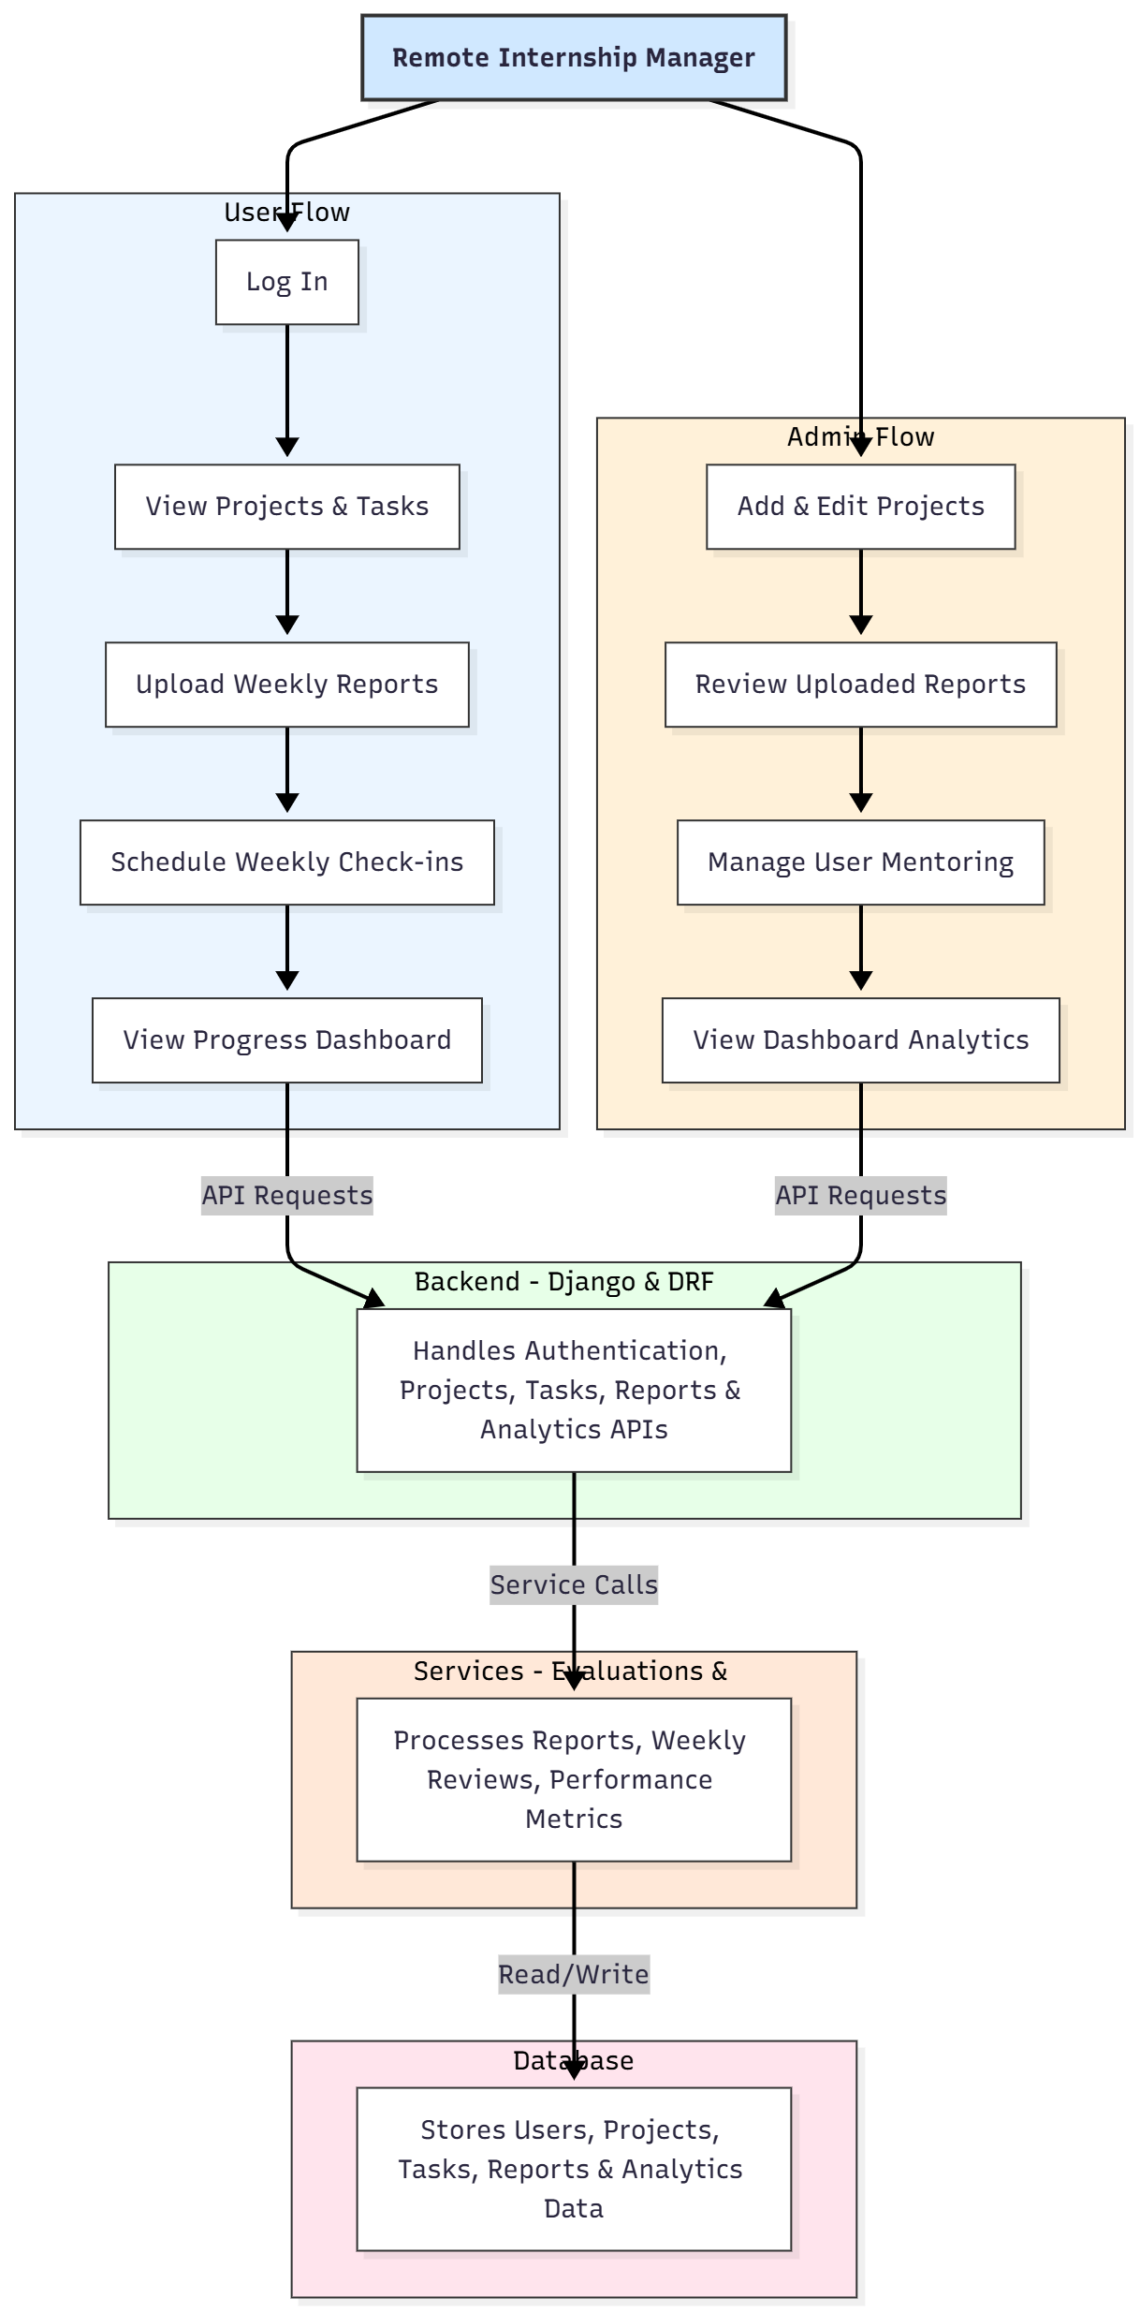

WORKING OF THE PROJECT:
The system begins when interns log in and view their assigned tasks and projects. They can upload weekly reports, which are stored in the backend and forwarded to the administrator for review. Interns can also schedule weekly check-in sessions for mentorship discussions. Meanwhile, administrators manage project assignments, evaluate uploaded reports, and track intern performance through interactive dashboards. The service module processes progress data, calculates metrics, and updates analytics in real time. The database stores comprehensive records of interns, tasks, reports, reviews, and project information, enabling smooth and structured internship management..

SOFTWARE REQUIREMENT:
- Backend:
  - Python 3.x
  - Django
  - Django REST Framework
  - SQLite/PostgreSQL
- Frontend:
  - Node.js and npm
  - React.js
  - Axios
- Development Tools:
  - Visual Studio Code
  - Postman (for testing APIs)
  - Git/GitHub (for version control)
- Server/Deployment (Optional):
  - Gunicorn, Nginx, or Heroku/AWS for hosting

ADVANTAGES OF THE PROJECT:

• Structured and transparent remote internship management
• Weekly reporting and review automation
• Real-time dashboard insights for interns and mentors
• Efficient project and task management
• Reduces administrative workload and manual tracking
• Ensures consistent communication and evaluation
• Enhances intern engagement and learning outcomes
• Suitable for educational institutions and HR departments

APPLICATIONS OF THE PROJECT:
• Ed-tech platforms
• Corporate HR departments
• Universities and student training offices
• Remote mentorship programs
• Internship monitoring systems
• Research lab training programs

REFERENCES:

- Django REST Framework Documentation — Django Software Foundation. Django Documentation. Available: https://docs.djangoproject.com/
- Django REST Framework. DRF Documentation. Available: https://www.django-rest-framework.org/
- React. React Official Documentation. Available: https://reactjs.org/docs/getting-started.html
- Redux. Redux Documentation. Available: https://redux.js.org/introduction/getting-started
- PostgreSQL Global Development Group. PostgreSQL Documentation. Available: https://www.postgresql.org/docs/
- MySQL. MySQL Reference Manual. Available: https://dev.mysql.com/doc/
- Git. Git Documentation. Available: https://git-scm.com/doc
- Node.js. Node.js Documentation. Available: https://nodejs.org/en/docs/
- Axios. Axios Documentation. Available: https://axios-http.com/docs/intro
- Socket.io Documentation – https://socket.io/docs/

